**S.THINESH**

**E/15/366**

**CO327 – Operating Systems**

**Assignment 1**

1. We have stressed the need for an operating system to make efficient use of the computing hardware. When is it appropriate for the operating system to forsake this principle and to “waste” resources? Why is such a system not really wasteful?

The use of computer resources must be maximized for the user in single user system.

Such a system is not really wasteful because although a graphical user interface may waste CPU cycles, but by maximizing the use of the system, it optimizes the user’s interaction with the system.

1. What is the main difficulty that a programmer must overcome in writing an operating system for a real-time environment?

Operating system keeps within the fixed time constraints of a real time system.

The main difficulty is the fact that there are already a lot of hard real time operating systems out there, published as source code, and it’s hard to come up with something new which beats them.

1. How does the distinction between kernel mode and user mode function as rudimentary form of protection (security) system?

The kernel mapping can partially overlap a user mode map.

This allows the kernel to share some of its privileges to a more limited level user mode. This also allows the kernel to examine/copy data from the user memory map, or just change its mapping to contain the user pages, and give the user memory map different pages (this can be faster than copying).

Thus having a dual mapping becomes more powerful, as it allows a hierarchy of mapping and granting different privileges to different mappings. Specifically, this can allow user mode drivers to access some device registers… It can also allow the emulation of as many security levels as the operating system requires.

Care must be taken, because some device registers might be able to bypass the memory mapping - so this level isn’t done that often.

The way these memory maps are manages is by designating a group of data (a context, which has CPU registers and status, extended security flags in addition to the memory map) and call it a process.

1. Some early computers protected the operating system by placing it in a memory partition that could not be modified either user job or operating system itself. Describe two difficulties that you think could arise with such a scheme.

The data required by the operating system ( passwords , access controls, accounting information, and so on) would have to be stored in or passed through unprotected memory and thus be accessible to unauthorized users.

The operating system could never be updated or patched, since it is not modifiable or accessible by the user or the operating system itself.

1. Give two reasons why caches are useful. What problems do they solve?

What problem do they cause? If a cache can be made as large as the device for which it is caching (for instance, a cache as large as a disk), why not make it that large and eliminate the device?

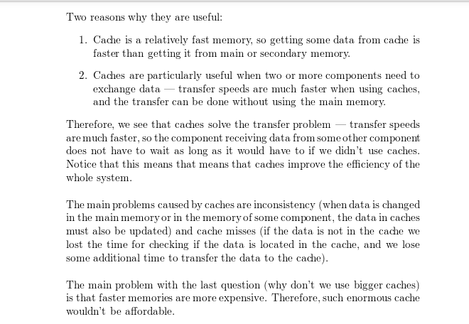

1. In a multiprogramming and time-sharing environment, several users share the system simultaneously. This situation can result in various security problems.
2. What are two such problems?

Stealing or copying one’s programs or data; using system resources (CPU, memory, disk space, peripherals) without proper accounting.

1. Can we ensure the same degree of security in a time-shared machine as in a dedicated machine? Explain your answer.

Probably not, since any protection scheme devised by humans can inevitably be bro-ken by a human, and the more complex the scheme, the more difficult it is to feel confident of its correct implementation.

1. Describe the differences between symmetric and asymmetric multiprocessing. What are three advantages and one disadvantage of multiprocessor system?

**Symmetric processing** treats all processors as equals; I/O can be processed on any of them.

**Asymmetric processing** designates one CPU as the master, which is the only one capable of performing I/O; the master distributes computational work among the other CPUs.

* Advantages : Multiprocessor systems can save money, by sharing power supplies, housings, and peripherals. Can execute programs more quickly and can have increased reliability.
* Disadvantages : Multiprocessor systems are more complex in both hardware and software. Additional CPU cycles are required to manage the cooperation, so per-CPU efficiency goes down.

1. How are network computers different from traditional personal computers? Describe some usage scenarios in which it is advantageous to use network computers?

A network computer is also called a thin client. These are terminals which can implement web based computing. In order to fulfil its computational needs it is heavily dependent on other server. Example: Remote Desktop Services Tradition computers on the other hand are standalone systems which has its own CPU and all the computational needs can be fulfilled by the system alone. Example: Personal computer used at homes. Network computers are used in following places.

1.Most of the financial firms outsource their I.T operations to other companies. They establish a special area called ODC (Offshore development centers). In ODC thin clients are used to connect to the onsite servers. In this way data security can be maintained as all the data is maintained on the server and user has no way to copy the data on a local computer in an unauthorized manner. Even if the thin client is stolen the data is safe on the onsite server.

2. It also provides hardware resource optimization as the cost of cable, buses and I/O can be minimized by this approach and also the processing power can be utilized by the user session that needs it the most.

3. Software maintenance can be reduced by using network computer as all the software patches and updates and OS migration can be rolled out for all users in one go.

1. What is the purpose of interrupts? How does an interrupt differ from a trap? Can traps can be generated intentionally by a user program? If so for what purpose?

The purpose of interrupts is to alter the flow of execution in response to some event. An interrupt is triggered in hardware and a trap is triggered in software. User programs can generate traps intentionally. They may want to interact with some I/O which requires a system call.

1. Direct memory access is used for high speed I/O devices in order to avoid increasing the CPU’s execution load.
2. How does the CPU interface with the device to coordinate the transfer?

All devices have hardware controllers. Normally, the OS has device drivers that communicate with the hardware controllers. The device drivers store arguments and results using registers and counters and buffers. These would tie up the CPU during the I/O. with direct memory access, the CPU first load them, and then the device controller takes over.

1. How does the CPU know when the memory operations are complete?

The device controller sends an interrupt signal.

1. The CPU is allowed to execute other programs while the DMA controller is transferring data. Does this process interfere with the execution of the user programs? If so, describe what forms of interference are caused.

You might say there is no interference with the user program, provided you discount interrupts. The DMA controller sends an interrupt when it is done this can cause a user process to be suspended.

1. Some computer systems do not provide a privileged mode of operation in hardware. Is it possible to construct a secure operating system for these computer systems? Give arguments both that it is and that it is not possible.

it would be very important to have a privileged mode of operation in hardware. If there's no kernel mode it would seem to difficult to protect against a hacker writing against the boot sector of a drive, or disabling interrupts and/or causing them.

1. Many SMP systems have different levels of caches; one level is local to each processing core, and another level is shared among all processing cores. Why are caching systems designed this way?

Recall one purpose of cache is to store frequently accessed data for efficient access. When the processor needs data that is not available in its cache, it can then access the cache shared by all of the processors. This is much more efficient each processor sharing the same cache. Why Just imagine the scheduling overhead for each processor to access data.

1. Describe a mechanism for enforcing memory protection in order to prevent a program from modifying the memory associated with other programs.

The processor could keep track of what locations are associated with each process and limit access to locations that are outside of a program’s extent. Information regarding the extent of a program’s memory could be maintained by using base and limits registers and by performing a check for every memory access.

1. Identify several advantages and several disadvantages of open-source operating systems. Include the types of people who would find each aspect to be an advantage or a disadvantage.

